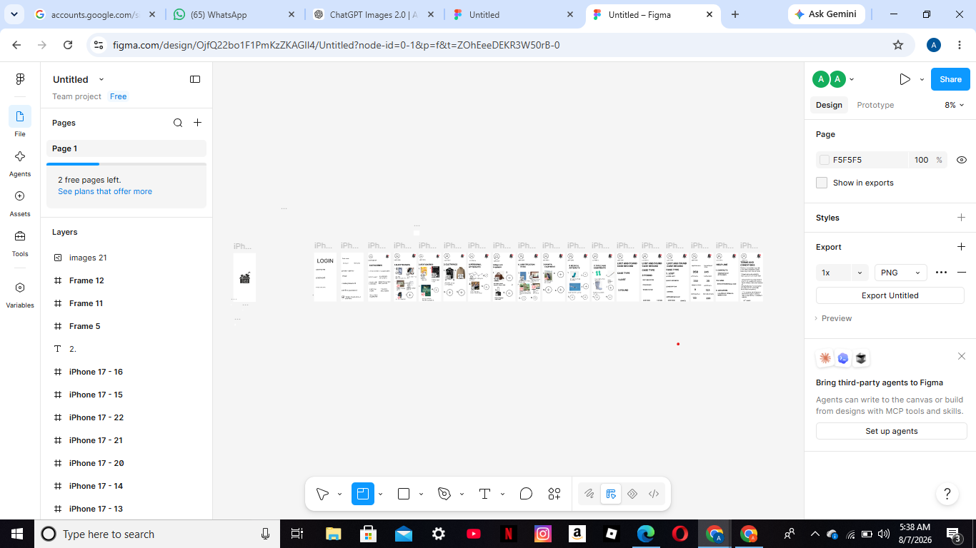lost and found management system
1.INTRODUCTION
A) Background of the problem
Many schools colleges and organizations experience problems with lost and found items. Records are often kept manually making it difficult to track items or retrieve lost property.
B) Purpose of the System
The purpose of the lost and found management system is to provide a computerized platform where users can report lost items, report found items, search for matching items, and manage claims efficiently
2.OBJECTIVES
A) General Objectives
To develop a computerized Lost and Found Management System that improves the management and recovery of lost items
B) Specific Objectives
1)To generate reports on lost found and claimed items.
2)To store and manage lost and found records securely.
3)To allow users to report lost and found items online.
3.USERS OF THE SYSTEM
A) Administrators
1. Manage users
2)Update system records
3)Approves claims
4)GENERATE REPORTS
B) Registered User
1.Report lost items.
2.Searches for found items.
3) Claim recovered items.
C)Finder
1) Report found items.
2) Uploads item details and photos.
4)FUNCTIONAL REQUIREMENTS
A)User registration and login
B)Report lost items
C)Report found items
D)Search for lost and found items
E)Claim and verify ownership of items
F)Generate reports
5)Non-Functional Requirements
a)Secure user authencation
b)Fast system response
c)System availailability24/7
6)User Personas
Persona 1
Name: Austine Wamalwa
Age:27
Occupation: Mixologist
Goals: To create a peaceful enviroment
Challenge: Financial instabiliy
Technical skills: Communication specialist
Expectation: Quick item search

Persona 2
Name: Richard Musa
Age:26
Occupation: accountant
Goals: Recover his lost phone
Challenges: Cannot find it was handed in
Technical skills :Basic computer skills
Expectation: Quick item search

Persona 3
Name: James Macharia
Age:24
Occupation: Security officer
Goals: Record found items
Challenges: Record found items
Technical skills: intermediate
Exception: Easy data entry

7.User Stories
1.As a student, I want to report a lost item so that item so that it can be found
2.As a finder , I want to report a found item so that the owner can claim it.

Software Development Life Cycle (SDLC)
MODEL: Waterfall Model
Justification
. Requirement are clearly defined.
. Each phase is completed before the next begins.
. Suitable for academic projects

